**VARUN BHARGAVA – 241010282**

**DATA STRUCTURES TASK-3**

**Task 01: Quick Sort:**

( https://github.com/varunnnb/dsa-sem3-iiitnr/blob/main/lab2/lab2-1.c )

Write a program to perform the following operations using the Quick Sort algorithm:

1. Take user input to create an array of integers.

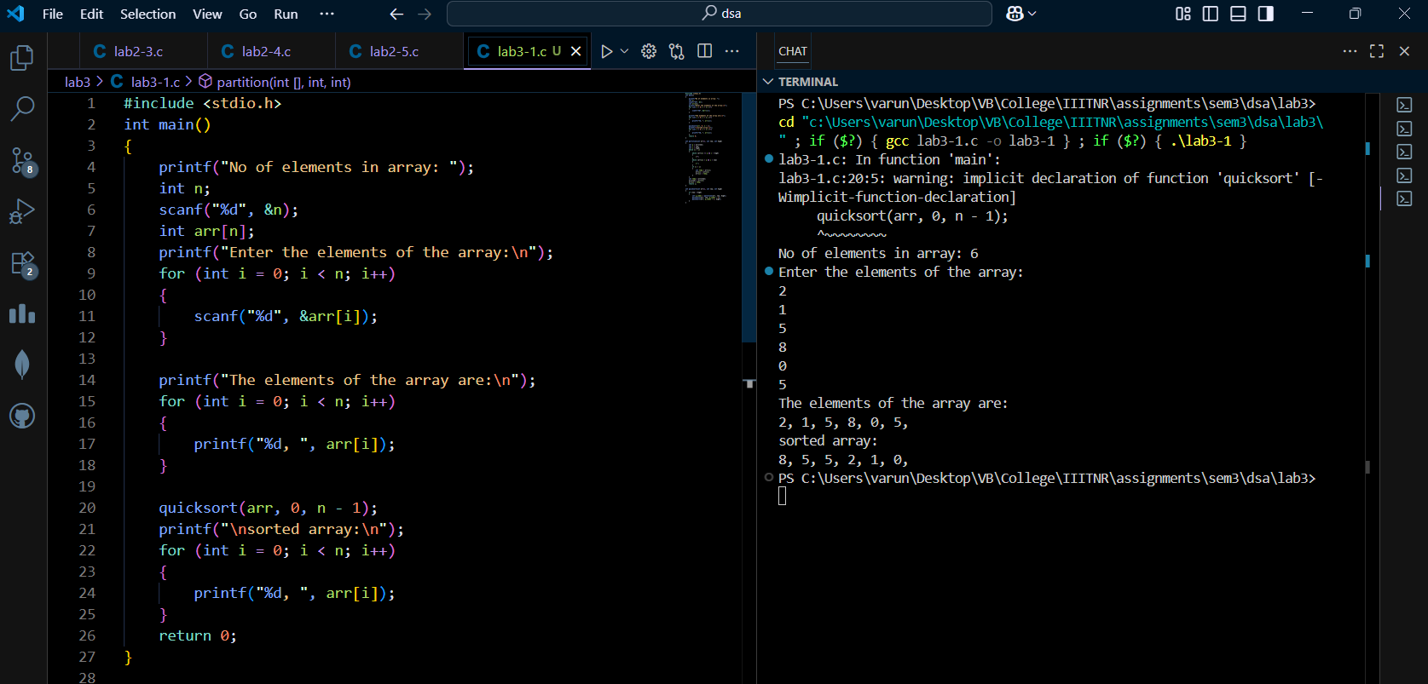

2. Sort the array in descending order using Quick Sort.

3. Display the sorted array.

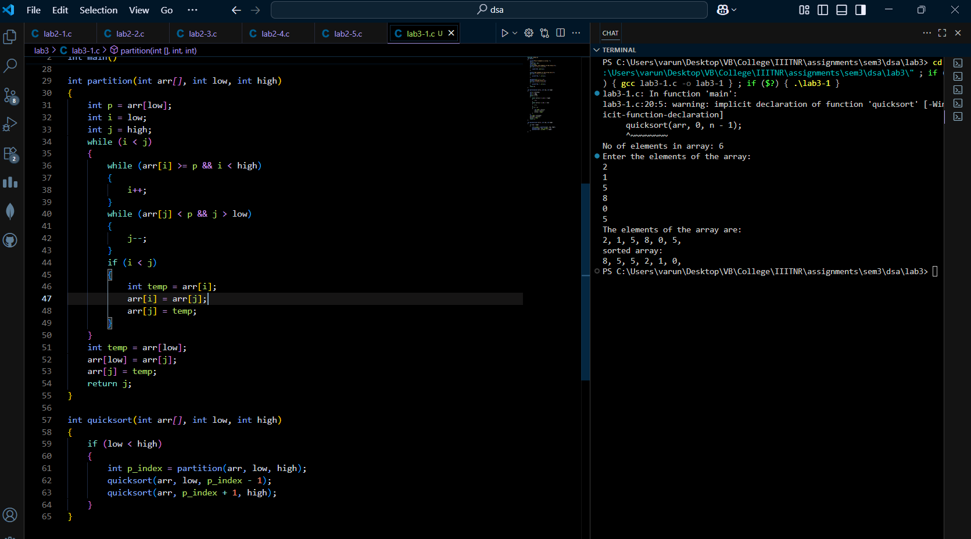

**Task 02: Merge Sort:**

( https://github.com/varunnnb/dsa-sem3-iiitnr/blob/main/lab2/lab2-2.c )

Write a program to perform the following operations using Merge Sort:

1. Take user input to create an array of integers.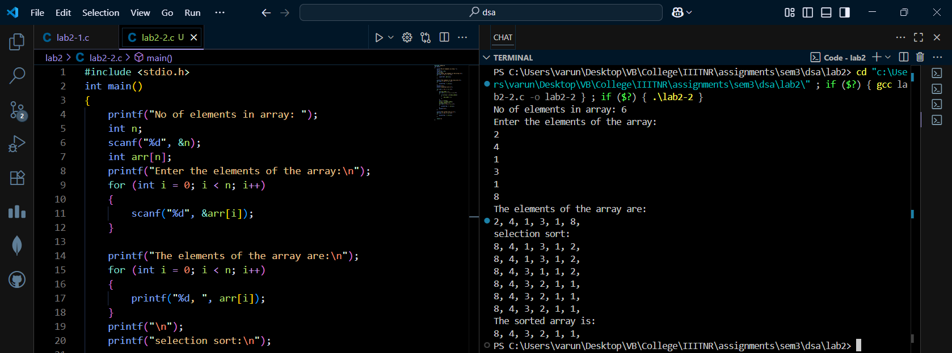

2. Sort the array in ascending order using the Merge Sort algorithm.

3. Display the sorted array.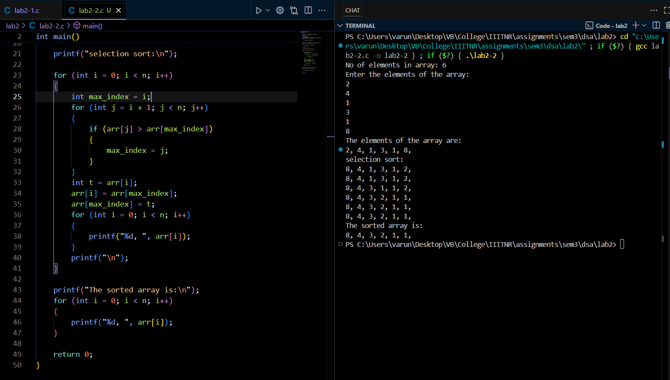

**Task 3: Linear Search:**

( <https://github.com/varunnnb/dsa-sem3-iiitnr/blob/main/lab2/lab2-3.c> )

Write a program to perform the following operations using Linear Search:

• Take user input to create an array of integers.

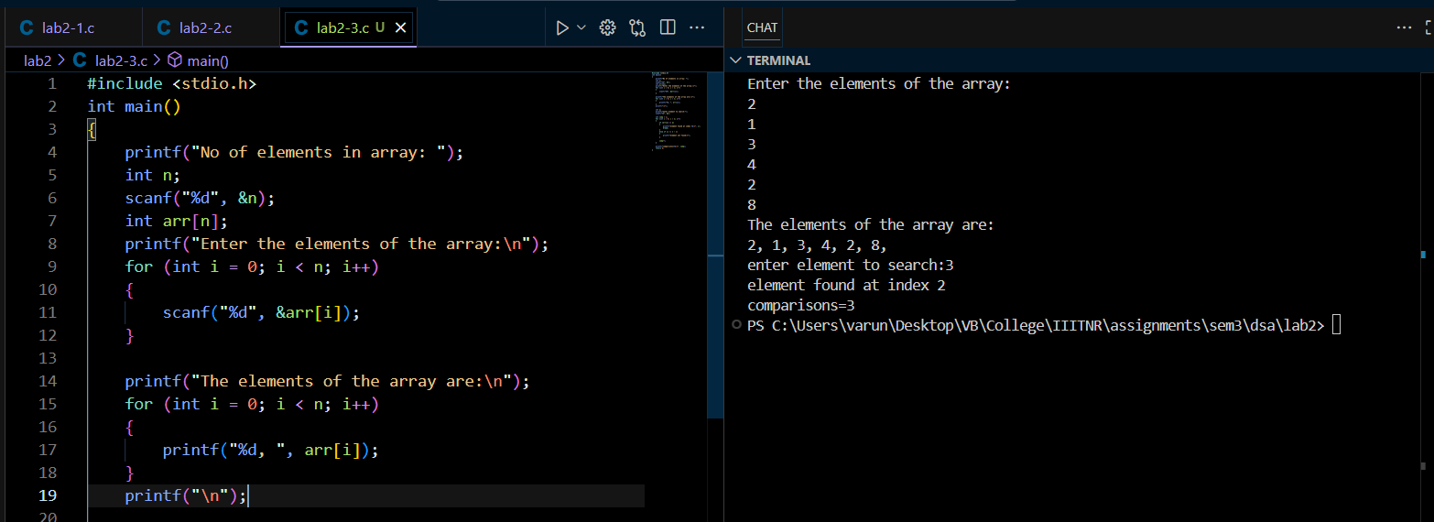

• Take input for the element to be searched in the array.

• Perform Linear Search:

– Display the index of the element if found.

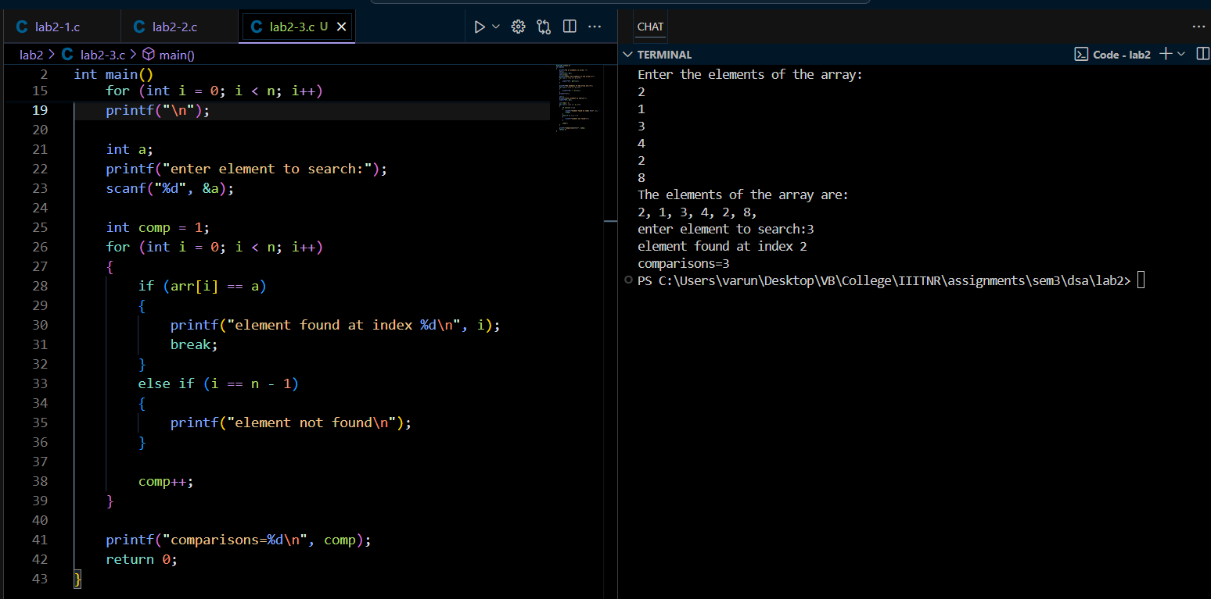

– If not found, display Element not found in the array.

• Display the number of comparisons made during the search.

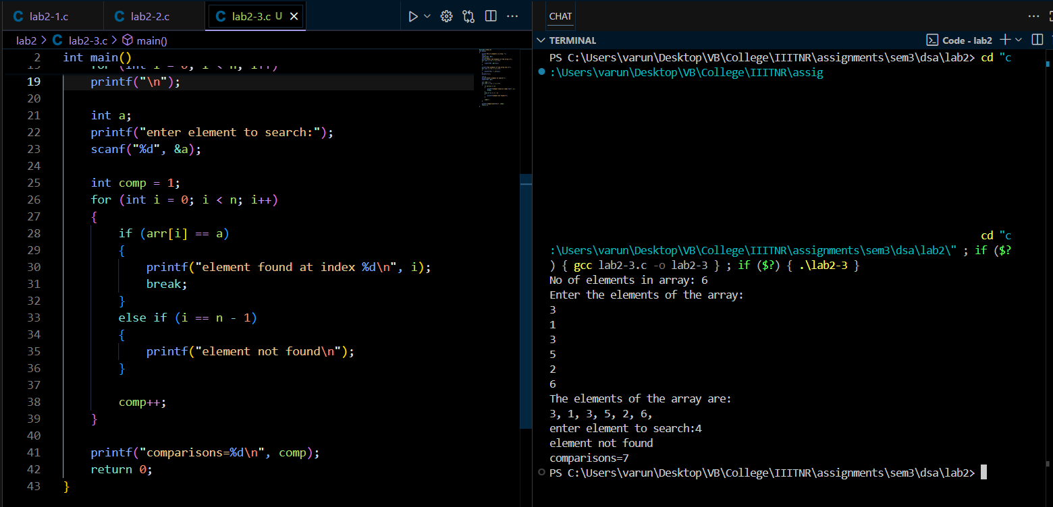

**Task 4: Binary Search:**

( <https://github.com/varunnnb/dsa-sem3-iiitnr/blob/main/lab2/lab2-4.c> )

Write a program to perform the following operations using Binary Search:

• Take user input to create a sorted array of integers.

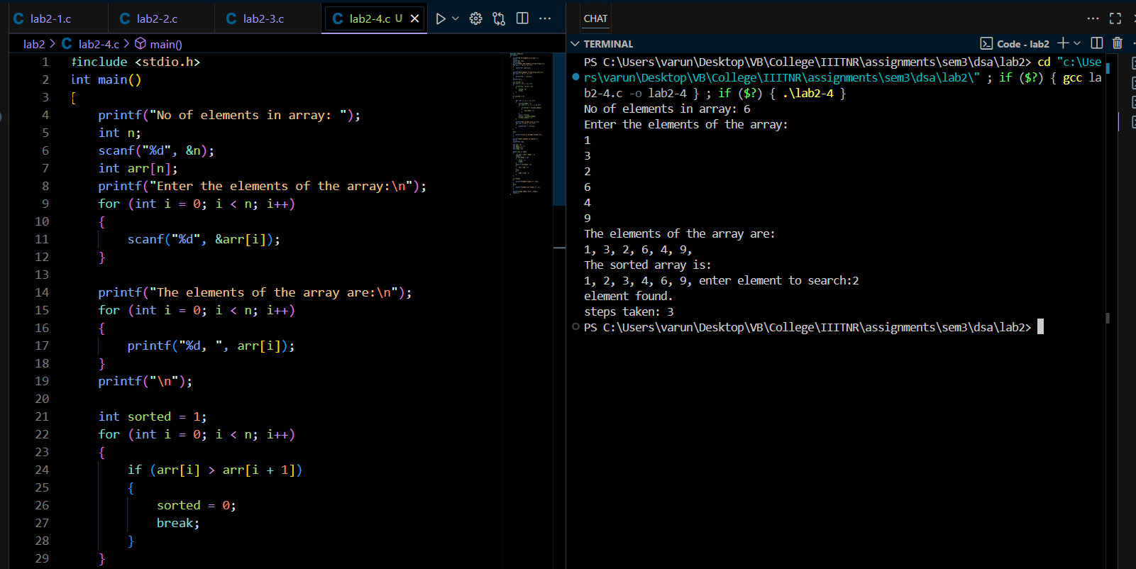

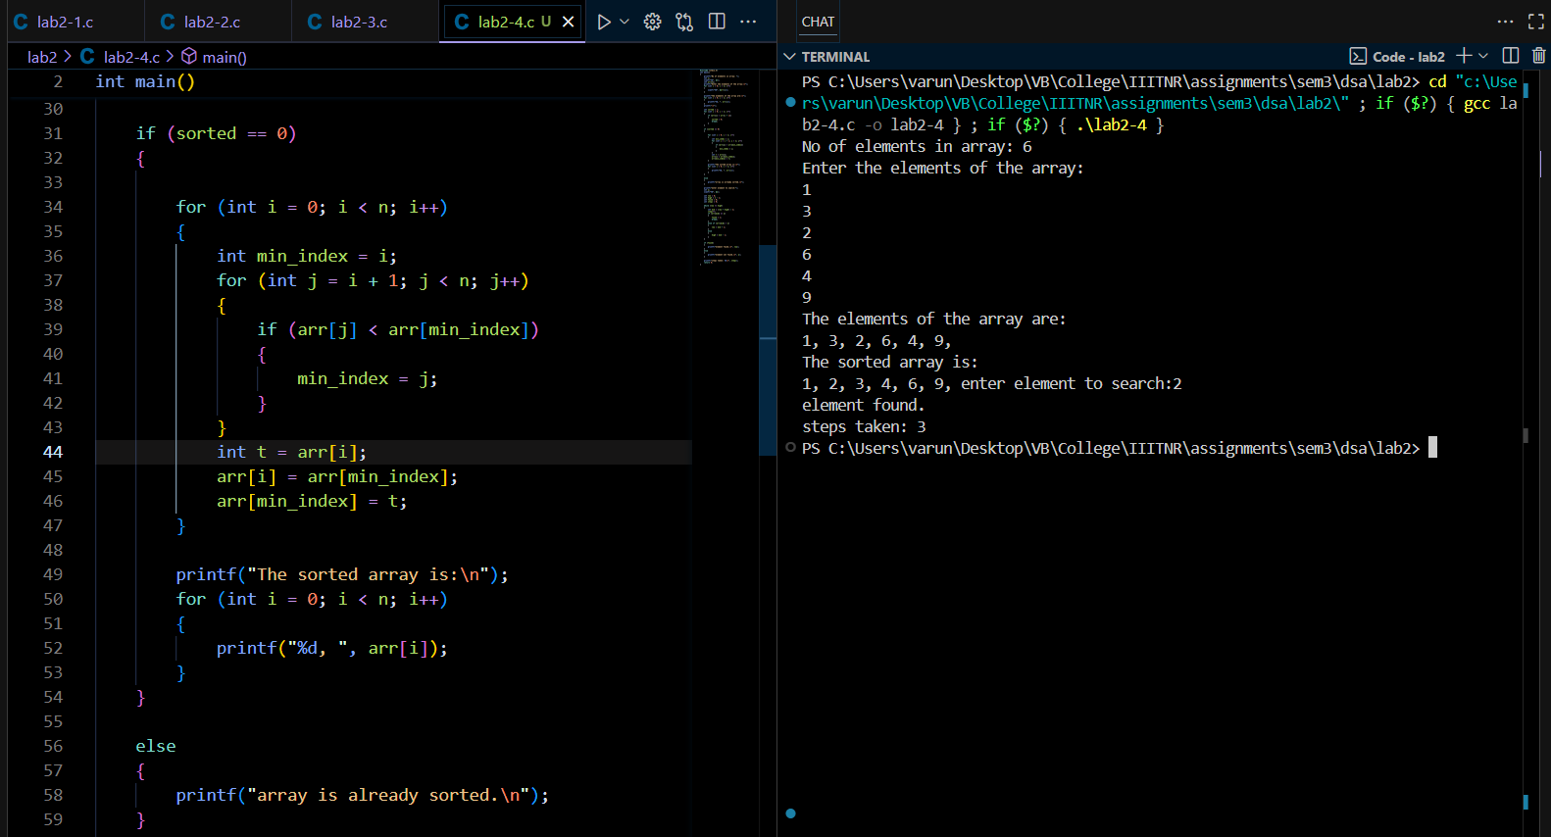

• Take input for the element to be searched in the array.

• Perform Binary Search:

– Display the index of the element if found.

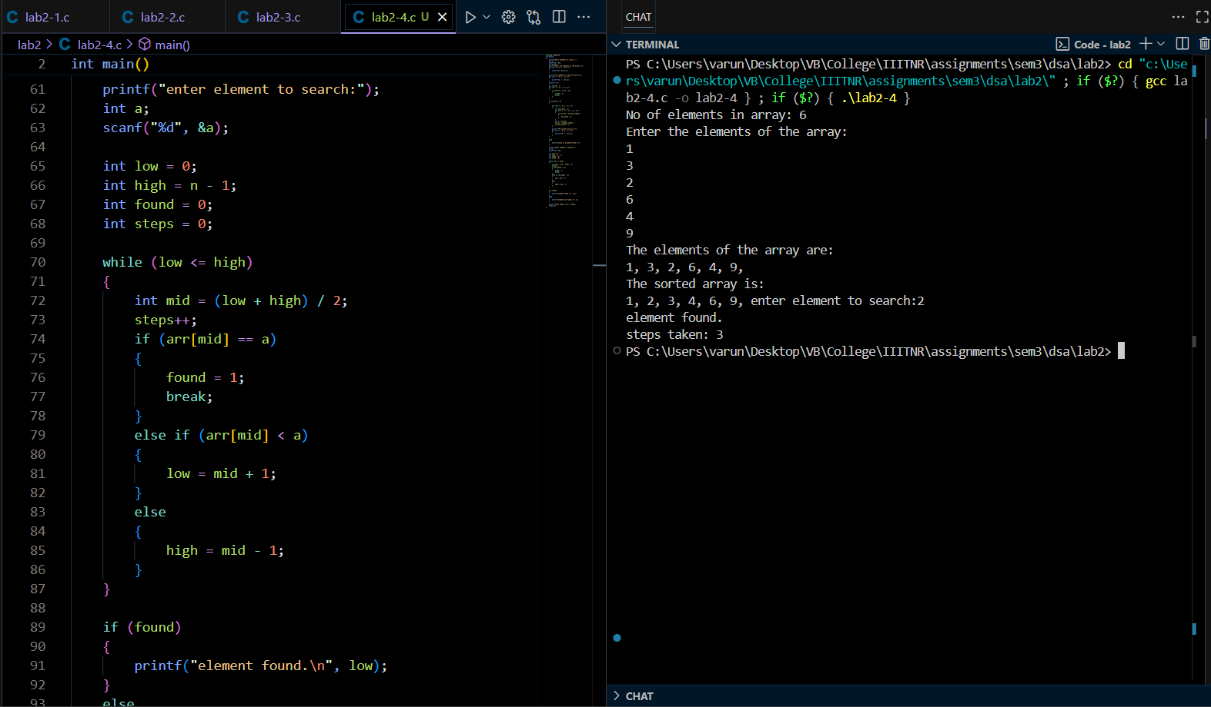

– If not found, display an appropriate message.

• Display the number of steps/iterations taken to find the element.

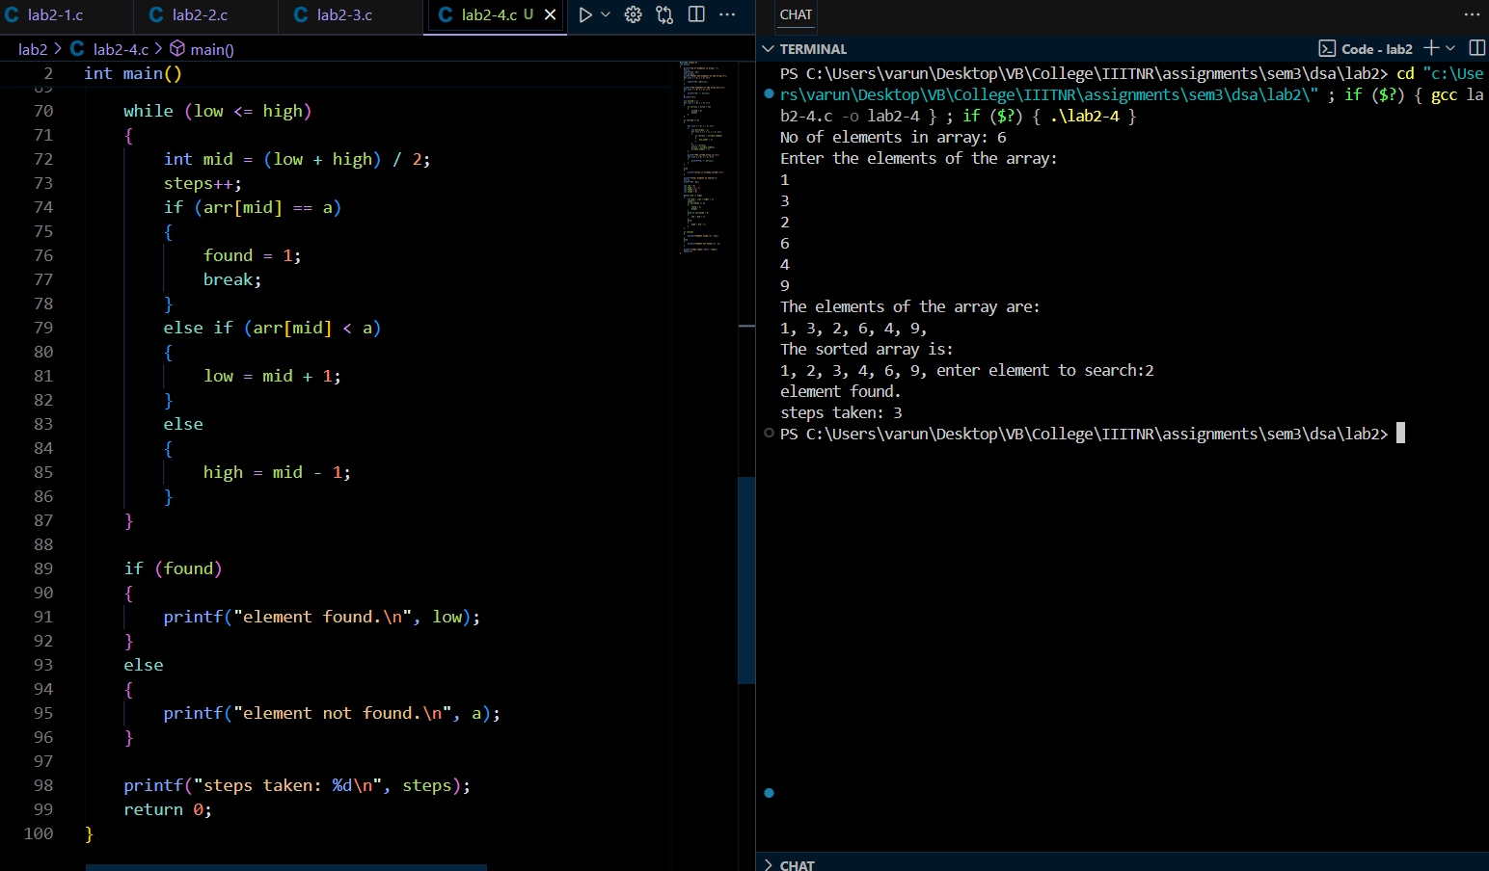

**Task 5: Matrix Multiplication Using Pointers:**

( <https://github.com/varunnnb/dsa-sem3-iiitnr/blob/main/lab2/lab2-5.c> )

Write a program to perform the following operations related to matrix multiplication:

• Declare three 2D matrices A[3][3], B[3][3], and C[3][3].

• Take user input to enter all elements of Matrix A and Matrix B using pointers.

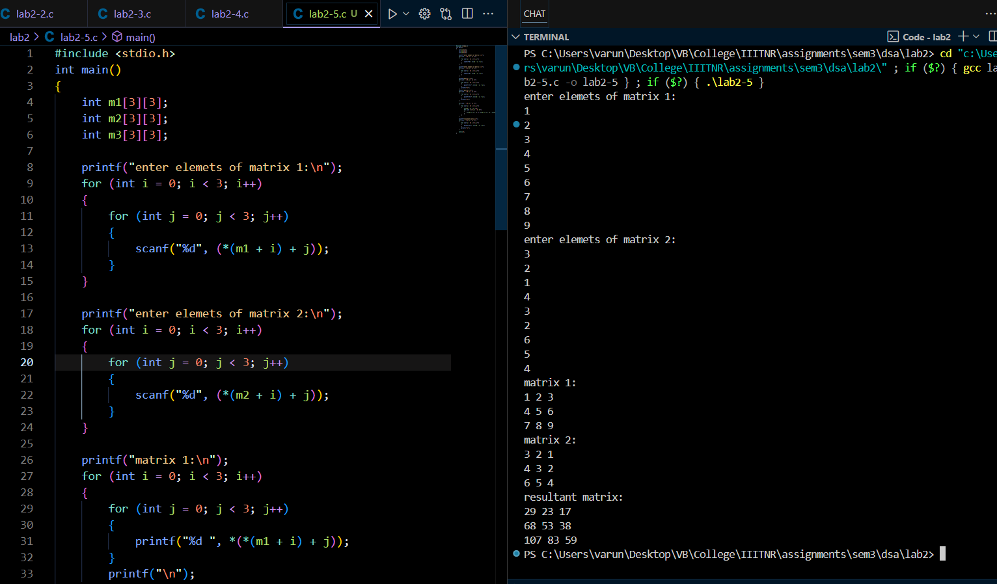

• Display both input matrices in matrix format.

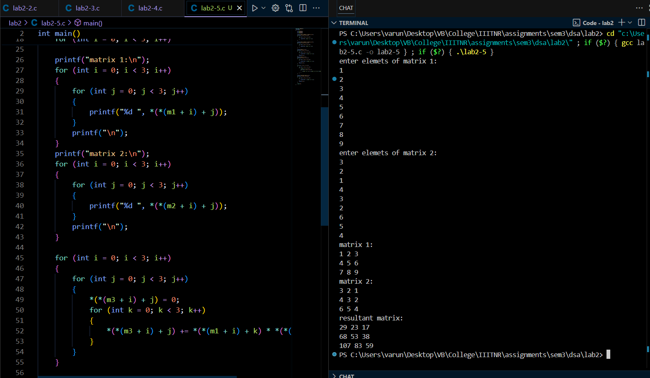

• Perform matrix multiplication using pointer arithmetic and store the result in Matrix C.

• Display the resultant matrix C in matrix format.

